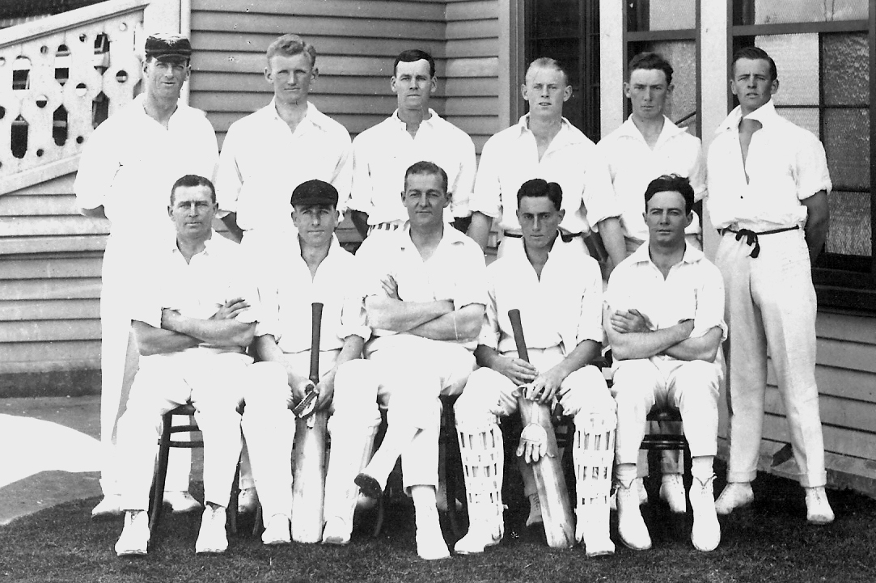

**Canterbury v Wellington 23 February 1923 Lancaster Park**

Canterbury 225 & 432 Wellington 370 & 173. Canterbury won by 114 runs and won the Plunket Shield

**Back row:** LR Brunton, J Newman, RJ Read, RO Talbot, WH Cunningham, RF Powell

**Front row:** DM Sandman, R de Worker, WR Patrick (captain), RC Blunt, GR Gregory